# Introduction:

This document describes the requirements of the “Study Based Assessment (SBA), which is required for the completion of the training. The target application is called “AngulAir”, a fictitious airline operating in the US. The project files delivered contain many gaps which need to be filled with code of AngularJS depending upon the requirements mentioned in this document.

# Instructions

Before working on this project, make sure that NodeJS is installed on your machine. This project uses a NodeJS based server internally. Once you have NodeJs installed, in the parent folder, run the following command (parent folder is the one which has the file package.json).

npm install

Once the above command finishes, now run “node index.js” in order to run the NodeJS server. Go to the URL <http://localhost:3000> to check if the server started successfully.

# Requirements

1. The tabs “Destinations”, “Flights” and “Reservations” are not high-lighted in the index.js. Add the relevant classes from the setActive() method defined in the controller to the ng-class directive. Refer to the line numbers 16, 19 and 22 of the file “index.js”
2. For the above requirement, the calls for setActive() are not properly implemented in the route configuration. Refer to the file app.js in the folder “lib”. The routes “/”, “/flights” and “/reservations” have a controller defined but will not make a call to the setActive() method. Add the required code on lines 7, 23. For flights, it’s already implemented.
3. Airports are not visible in the home page. Make a call to the server to get the airport. The path to get the airports is “/airports”. Refer to the services.js defined in the folder lib. The code to make calls to get airports, reservations and flight information is missing. Add the relevant paths in this file. Do not forget to add dependency to the module that contains $resource service.
4. Use the service Airport defined above to make a call to the server for the list of airports. Add the relevant code to the file app.js on the line number 49.
5. The scoped object currentAirport is not being set on the AirportCtrl defined on the line number 74. Add the relevant code in the controller to fill the object currentAirport by using the Airport service defined above. Use $routeParams to fetch the airport code from the URL.
6. The sidebar which displays the selected airport destinations is visible even if the current airport is not selected. Hide this sidebar by adding relevant code to the ng-show directive defined on the line number 1 of the file “partials\airport.html”.
7. The destinations are not displayed. Code does exist to iterate over the destinations of the selected airport, but the names are not displayed. Added the relevant expression on the line number 7 of the above file.
8. Apply the requirements 6 and 7 to the partial file “airports.html” also.
9. When the destinations tab loads, the airports are to be displayed. But in the current implementation, the destinations tab is empty. Add the relevant code in the ng-repeat directive to iterate over the airports and set the ng-click of the links to “setAirport” by passing the airport code as a parameter. Refer to the partial “destinations.html”
10. Add the directive ng-include to the div element defined on the last line of the above partial.
11. Fix the search operation of the flights tab by adding relevant code in the ng-model defined on the input elements of flights.html partial.
12. Fix the above code in the reservations.html partial as well.
13. Reserve functionality is not working in the reservations tab. Add the code to call reserveFlight() on the line number 6 of the reservations.html partial.

# Screenshots:

Screenshot 1: Destinations tab

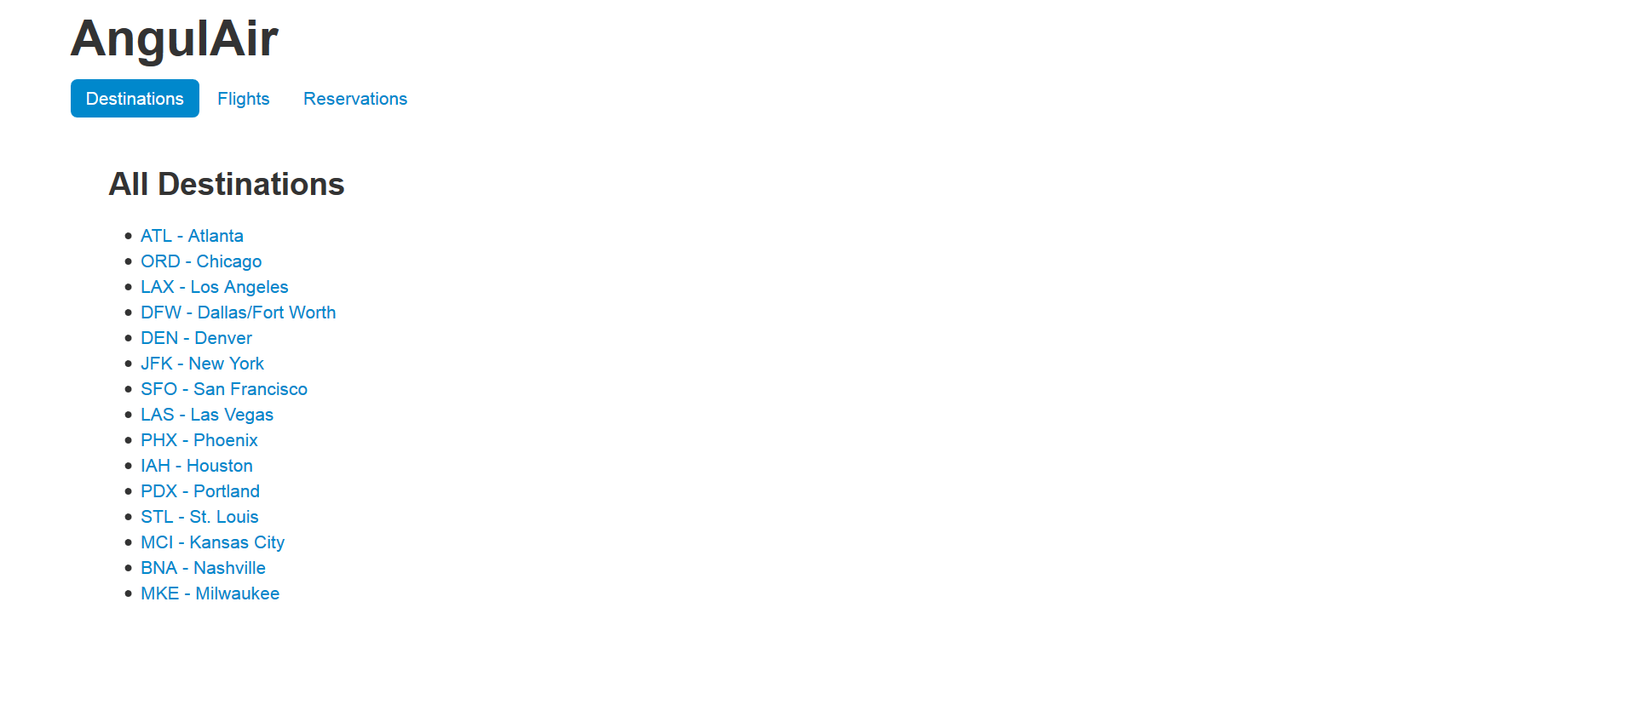

Screenshot 2: after selecting an airport from the destinations list

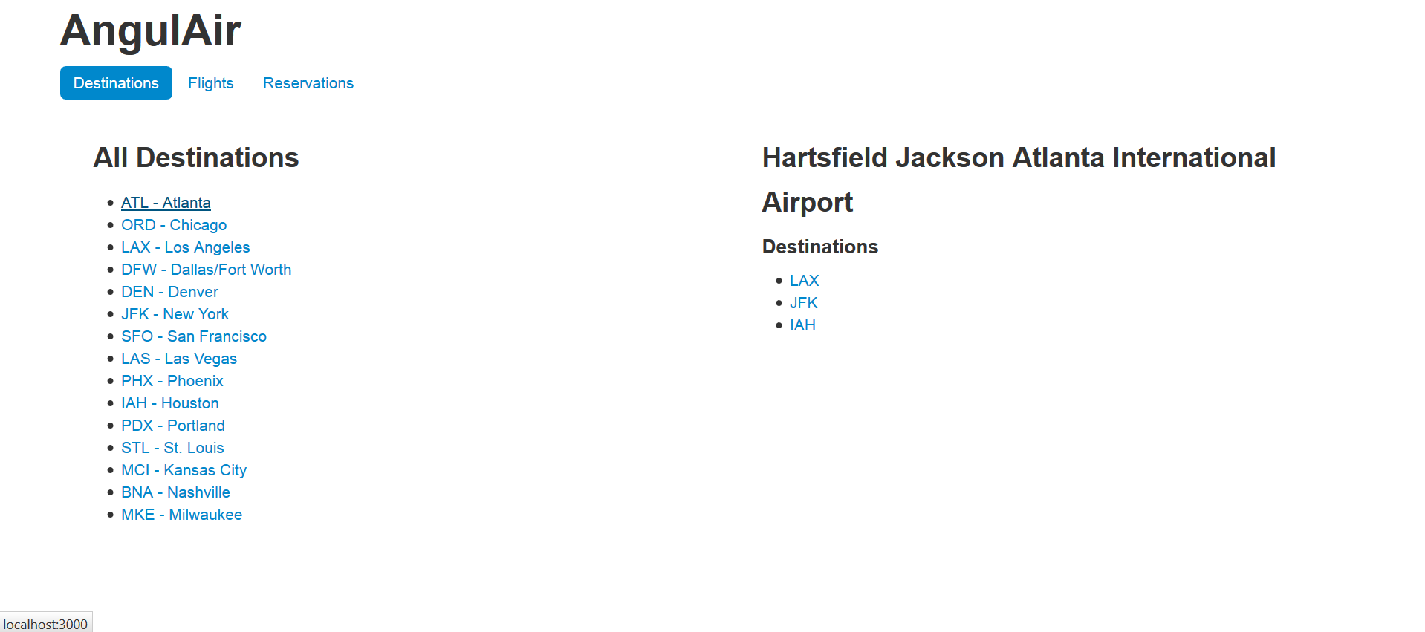

Screenshot 3 Flights tab:

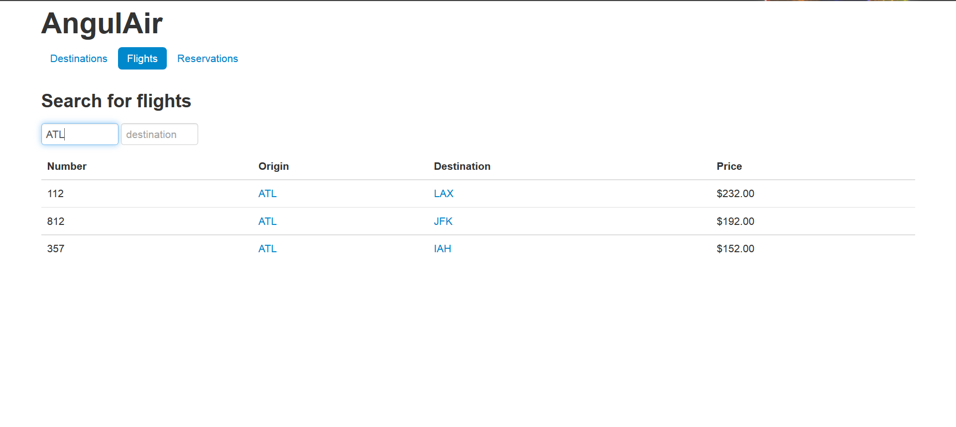

Screenshot 4: Reservations tab.

